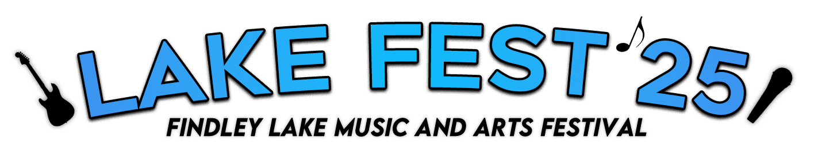

To our respected community members:

“*With a little help from our friends*”

**Findley Lake Forward is bringing you Lake Fest ‘25**

This year will be our first annual Findley Lake Music & Art Festival, aka LAKEFEST, and will take place July 12th and 13th. There will be a **dozen live music acts** **spread out across three different stages**, an **art gallery** in the firehall, **artisan vendors, drinks, food** and plenty of happenings throughout town. This will give our “coolest little town around” even more exposure and it will give those who are staying here for the summer an amazing experience that they won’t ever forget.

All Profits for Lakefest ‘25 will be used to help Findley Lake Forward fulfill our mission to: ***"Enrich the Findley Lake experience for residents and visitors by promoting a vibrant community."***

Naturally we will need help from our local community members to fund this event and get it done right. There are several levels of sponsorship, and every monetary contribution will help make this an event that will hopefully be the first of many. Please see the different options below to help us get this new event off to a great start!

Donation/Sponsorships

**Stage Sponsorships**: 3 Available

OOCC parking lot stage $1500

Watershed Gazebo stage $750

Alexander’s Gazebo stage $750

Name on: Posters // T-Shirts // Media Ads // Yard Signs // Stage

**Diamond Sponsorship** $250, 8 Available

Name on: Posters // T-Shirts // Media Ads // Yard Signs

**Gold Sponsorships** $125, 26 Available

Name on: Yard Signs // Media Ads

Name: ______________________________________________

Address: _____________________________________________

Email: _______________________________________________

Requested Name on T-Shirts/Posters: _____________________

____________________________________________________

Make Checks payable to: Findley Lake Forward

PO Box #82 Findley Lake NY 14736

Or drop off at Twin Docks/Alexander's/OOCC Stores

**Due 4/1/25**

Please respond back directly to [**danobrien1122@gmail.com**](mailto:danobrien1122@gmail.com) to reserve your sponsorship and forward your logo for printable material.